**

TAG CODE 3D – IMU_COFIG.CPP

* Apply axis mapping to ensure consistent coordinate system across ALL sensors
*
* Based on analysis of current Madgwick filter transformations in main.cpp:
* - Gyro: -gy, gx, -gz -> X=-Y, Y=X, Z=-Z
* - Accel: -ax, ay, -az -> X=-X, Y=Y, Z=-Z
* - Mag: mx, my, mz -> X=X, Y=Y, Z=Z
*
*
* Test reveals board z up = board face down
* Z down = board face up
* Y up = face to left
* Y down = face to right
* X up = nose up
* X down = nose down
*
*
*
*
*
*
*
*
* For consistency with your updateMadgwick() example, applying unified mapping
* to ensure all sensors use the same coordinate system for sensor fusion.
*/
void applyAxisMapping(float raw_x, float raw_y, float raw_z,
float& mapped_x, float& mapped_y, float& mapped_z) {
// Based on current gyroscope pattern in Madgwick filter for consistency:
// Gyro transformation: -gy, gx, -gz means X=-Y, Y=X, Z=-Z
mapped_x = -raw_y; // X becomes -Y
mapped_y = raw_x; // Y becomes X
mapped_z = -raw_z; // Z becomes -Z

// NOTE: This mapping is inferred from your current Madgwick filter calls
// Adjust based on your actual axis mapping test results if needed

13 – DEC – 25
Z – UP = board face down
Z-Down = board on table face up
Y – UP board face left
Y-DOWN = board face right
X-UP = board facing me
X-DOWN = board facing away from me

CORRECT ORIENTATION
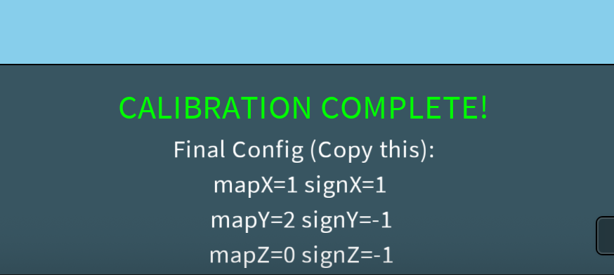

The task is 100% complete in
task.md
. The user is asking a conceptual question.

I'll answer the user's question clearly:

Yes, changes are only in Visualization.
Why this is good: Keeps firmware "honest" (raw data).
Real World Impact: Any flight controller using this sensor must have its "Board Orientation" set to match what we found (Yaw 180, Swap X/Y, etc).

You are 100% Correct.

We modified the Visualization (The "Receiver"), not the Firmware (The "Sender").

Why this is actually GOOD:
It is best practice for sensors to send "Truth" (Raw Data), and for the Application to decide how to use it.

The Firmware is now "Pure". It just says "Here is what the chip sees."
The Processing Sketch is configured to say "Okay, I know this chip is mounted sideways and backwards, so I will adjust."
Real World Impact:
If you plug this sensor into a Flight Controller (like Betaflight or ArduPilot), you will see the same "Wrong" behavior at first.

The Fix: You will simply go into that Flight Controller's settings and enter the Board Alignment (e.g., Yaw: 180, Roll: 270), just like we did with the T key and code here.
You have a working, calibrated system! 🚀

